
ACTIVITY 3:


Bacterial resistance to antibiotics:
An authentic experience
This project has received funding from the European Union's Horizon 2020 Research and Innovation Programme Under Grant Agreement No. 101006255.

Cite as:
Drymiotou, I., Biobank.cy, UNIC Medical School and Cp. Foodlab (2024). Activity 3. Bacterial resistance to antibiotics: An authentic experience. In Antimicrobial Resistance. MULTIPIERS project. Students’ material. Nicosia
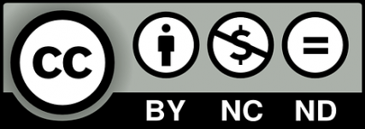
Distributed under Creative Commons License.
Attribution (BY)-NONCommercial-NoDerivs-4.0 International.

BACTERIAL RESISTANCE TO ANTIBIOTICS: AN AUTHENTIC EXPERIENCE.
- Do you know any experts in AMR?
Have you ever met an expert in AMR? Well, this activity will guide you to learn more about the experts’ profile (e.g., studies, previous work experience, hobbies).
To start with, the card below will help you to summarise the information about the experts. When you first meet the expert(s) you can ask different questions (e.g., What skills do you need to have to be molecular biologist?) and fill in this profile card.

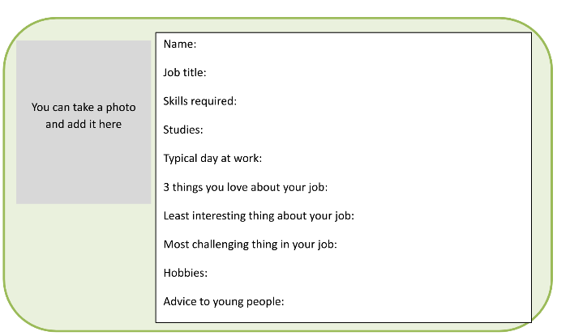

- Bacterial resistance to antibiotics.
How can you tell that an antibiotic is working?
Apply the antibiotic diffusion discs to agar surface with a colony of a bacterium.
- What can you see? Write your observations for each one of the antibiotic diffusion disks.

- Based on your observations, can you explain how do the antibiotic diffusion disks work?
_______________________________________________________
_______________________________________________________
_______________________________________________________
_______________________________________________________

- Identify the various forms of bacteria.
These may look like jelly beans but they actually represent different bacteria. Look at each petri dish and identify the bacteria. Write the name of the bacteria in each box below:

- Spot saliva bacteria!
Collect saliva from your mouth using a swab and place it on a slide and cover it with a clear glass or plastic to minimise evaporation and protect the microscope lens from exposure to the sample.
What can you see? Write your observations!
___________________________________________________________
___________________________________________________________
___________________________________________________________

- Spot bacteria on your hands!
Place your hands under the UV lamp. What do you observe?
___________________________________________________________
___________________________________________________________

Now, wash your hands with water and place again your hands under the UV lamp. What do you observe?
___________________________________________________________
___________________________________________________________

Now, wash your hands with water and soap and place again your hands under the UV lamp. What do you observe?
___________________________________________________________
___________________________________________________________

What is your conclusion?
___________________________________________________________
___________________________________________________________

- Simulated Patient Consulation!
What do you think about the patient’s attitude?
___________________________________________________________
___________________________________________________________
Do you think that the doctor should have prescribed antibiotics?
___________________________________________________________
___________________________________________________________

Imagine that you are the doctor, what advice would you give to the patient?
___________________________________________________________
___________________________________________________________

